Star Shape
# Source: AI Source: Provided by: [Data Path: Persons Table -> ID Column: 1, Name_En Column: Motasem Essam] -> From: [ChatGPT] on [7/25/2026]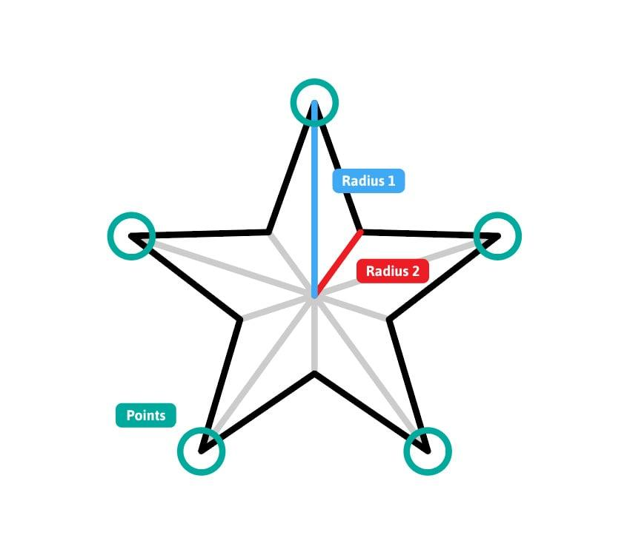
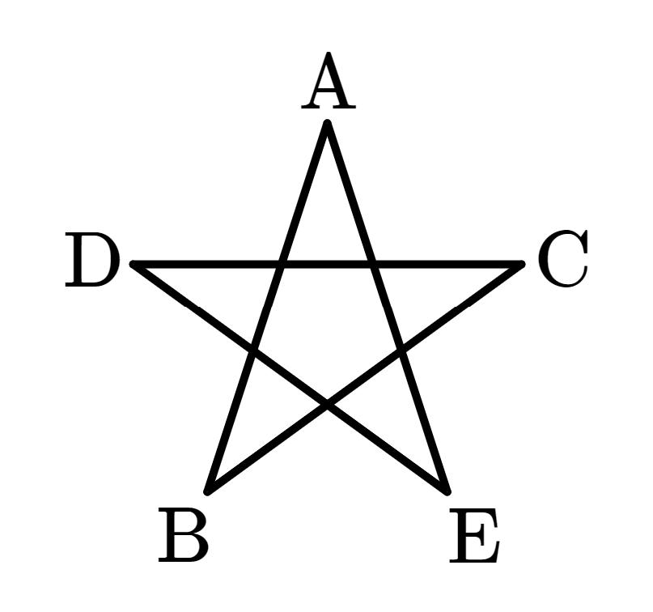
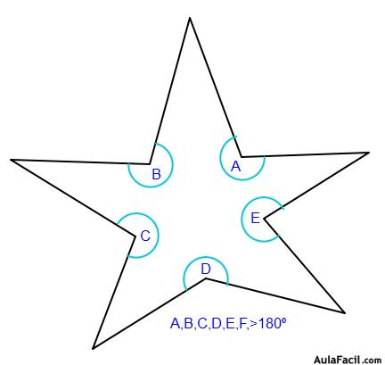
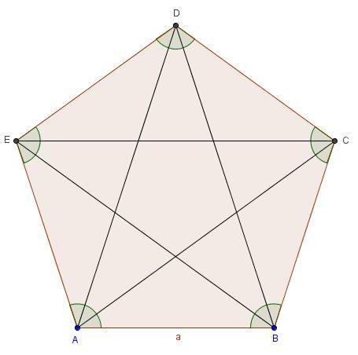
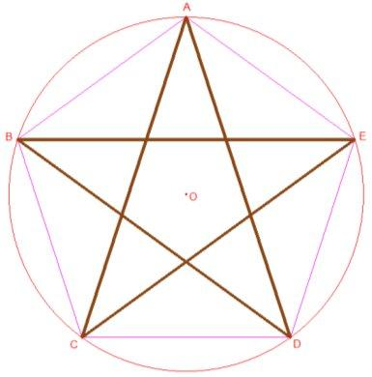

Definition
# Source: AI Source: Provided by: [Data Path: Persons Table -> ID Column: 1, Name_En Column: Motasem Essam] -> From: [ChatGPT] on [7/25/2026]
A star shape is a geometric shape with a central region and outward-pointing projections called points or tips, giving it the appearance of a star.
In geometry, a star shape may be represented by a star polygon, a concave polygon, or, in some cases, a self-intersecting polygon.
The term star shape is therefore broader than the specific mathematical term star polygon.

Fundamental Concept
# Source: AI Source: Provided by: [Data Path: Persons Table -> ID Column: 1, Name_En Column: Motasem Essam] -> From: [ChatGPT] on [7/25/2026]
A typical star shape consists of alternating:
- Outer vertices — the tips of the star.
- Inner vertices — the inward points between the tips.
- Edges — segments connecting consecutive vertices.
- Central region — the area around the center.
For a common five-pointed star:
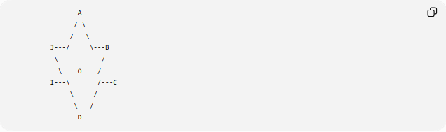
A
/ \
/ \
J---/ \---B
\ /
\ O /
I---\ /---C
\ /
\ /
D
The exact geometry depends on how the vertices are connected.

Classification
# Source: AI Source: Provided by: [Data Path: Persons Table -> ID Column: 1, Name_En Column: Motasem Essam] -> From: [ChatGPT] on [7/25/2026]
A useful geometric classification is:
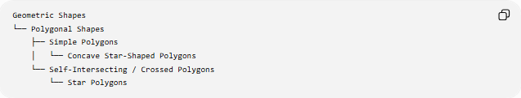
Geometric Shapes
└── Polygonal Shapes
├── Simple Polygons
│ └── Concave Star-Shaped Polygons
└── Self-Intersecting / Crossed Polygons
└── Star Polygons
However, not every visual star shape is a star polygon.

Types of Star Shapes

1. Simple Star Shape
# Source: AI Source: Provided by: [Data Path: Persons Table -> ID Column: 1, Name_En Column: Motasem Essam] -> From: [ChatGPT] on [7/25/2026]
A simple star shape has inward and outward vertices but its boundary does not cross itself.
It is a concave polygon.
Simple Star Shape
└── Concave Polygon
The boundary forms one continuous, non-self-intersecting outline.

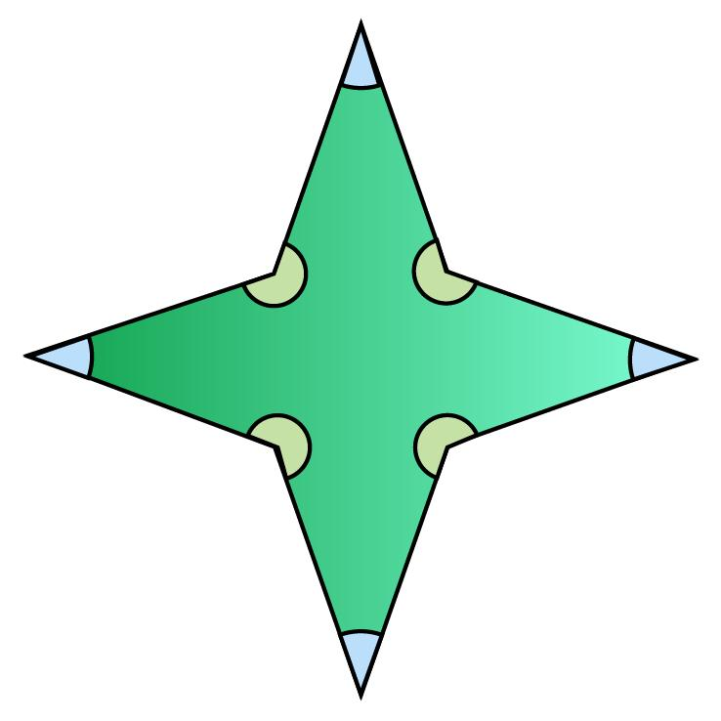
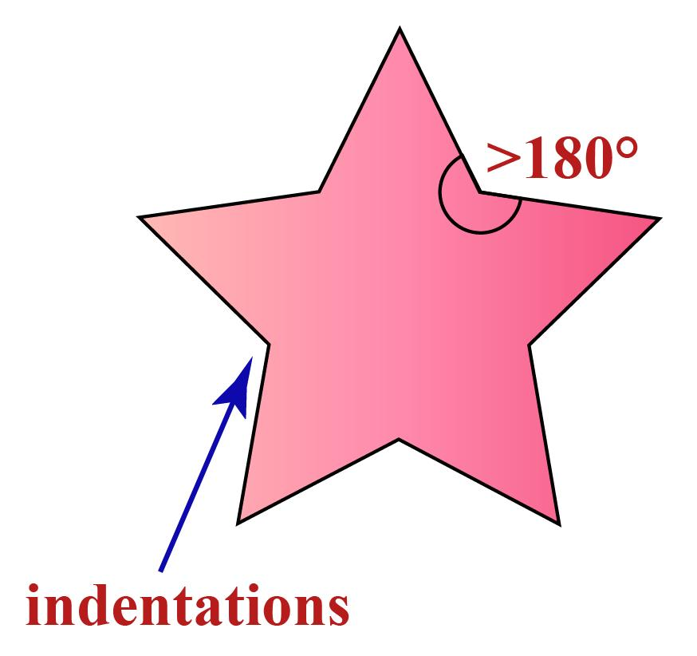

2. Star Polygon
# Source: AI Source: Provided by: [Data Path: Persons Table -> ID Column: 1, Name_En Column: Motasem Essam] -> From: [ChatGPT] on [7/25/2026]
A star polygon is a polygon whose edges create a star-like pattern according to a regular geometric construction.
A common example is the pentagram.

Common Examples of Star Polygons
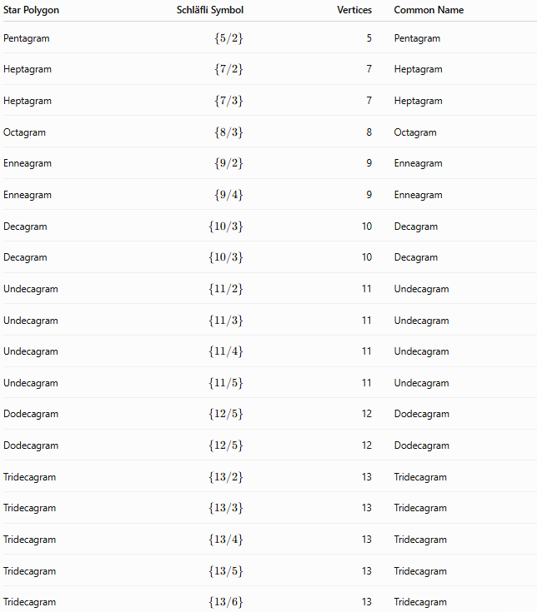
Star Polygon | Schläfli Symbol | Vertices | Common Name
Pentagram | $$\left\{5/2\right\}$$ | 5 | Pentagram
Heptagram | $$\left\{7/2\right\}$$ | 7 | Heptagram
Heptagram | $$\left\{7/3\right\}$$ | 7 | Heptagram
Octagram | $$\left\{8/3\right\}$$ | 8 | Octagram
Enneagram | $$\left\{9/2\right\}$$ | 9 | Enneagram
Enneagram | $$\left\{9/4\right\}$$ | 9 | Enneagram
Decagram | $$\left\{10/3\right\}$$ | 10 | Decagram
Decagram | $$\left\{10/3\right\}$$ | 10 | Decagram
Undecagram | $$\left\{11/2\right\}$$ | 11 | Undecagram
Undecagram | $$\left\{11/3\right\}$$ | 11 | Undecagram
Undecagram | $$\left\{11/4\right\}$$ | 11 | Undecagram
Undecagram | $$\left\{11/5\right\}$$ | 11 | Undecagram
Dodecagram | $$\left\{12/5\right\}$$ | 12 | Dodecagram
Dodecagram | $$\left\{12/5\right\}$$ | 12 | Dodecagram
Tridecagram | $$\left\{13/2\right\}$$ | 13 | Tridecagram
Tridecagram | $$\left\{13/3\right\}$$ | 13 | Tridecagram
Tridecagram | $$\left\{13/4\right\}$$ | 13 | Tridecagram
Tridecagram | $$\left\{13/5\right\}$$ | 13 | Tridecagram
Tridecagram | $$\left\{13/6\right\}$$ | 13 | Tridecagram

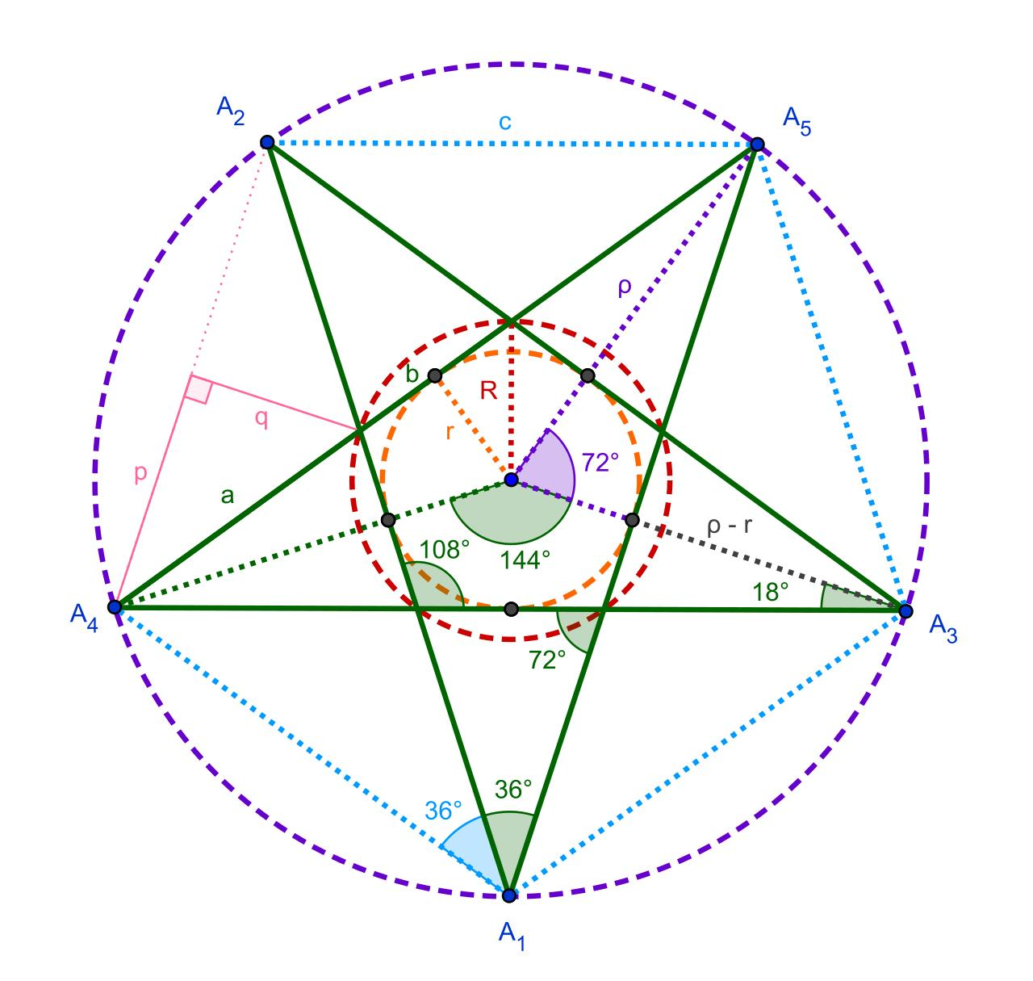
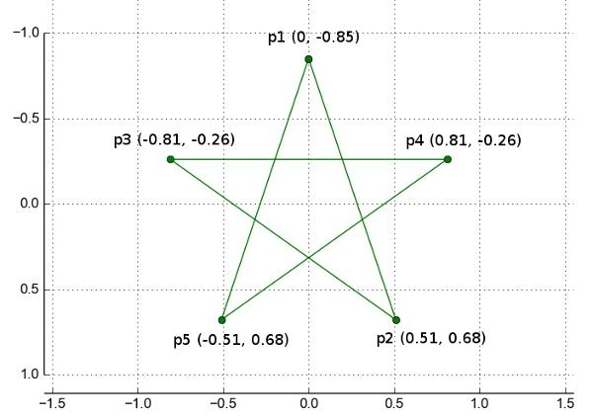
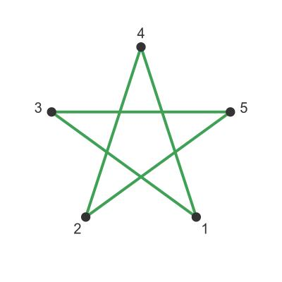
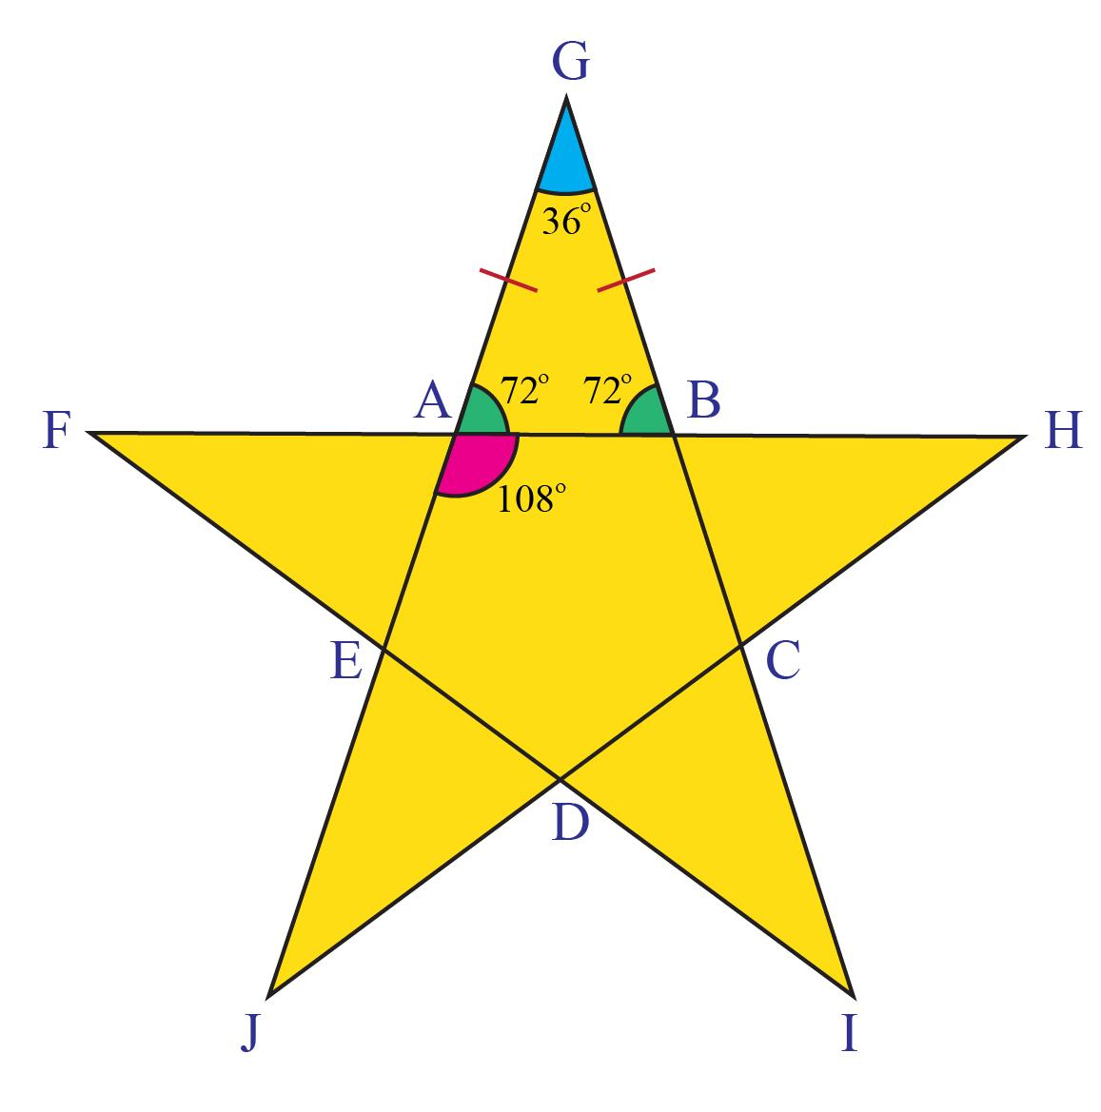
The pentagram is written using Schläfli notation as:
$$\left\{5/2\right\}$$
This means:
- $5$vertices are used.
- Each vertex connects to the second vertex around the circle rather than the immediately adjacent one.
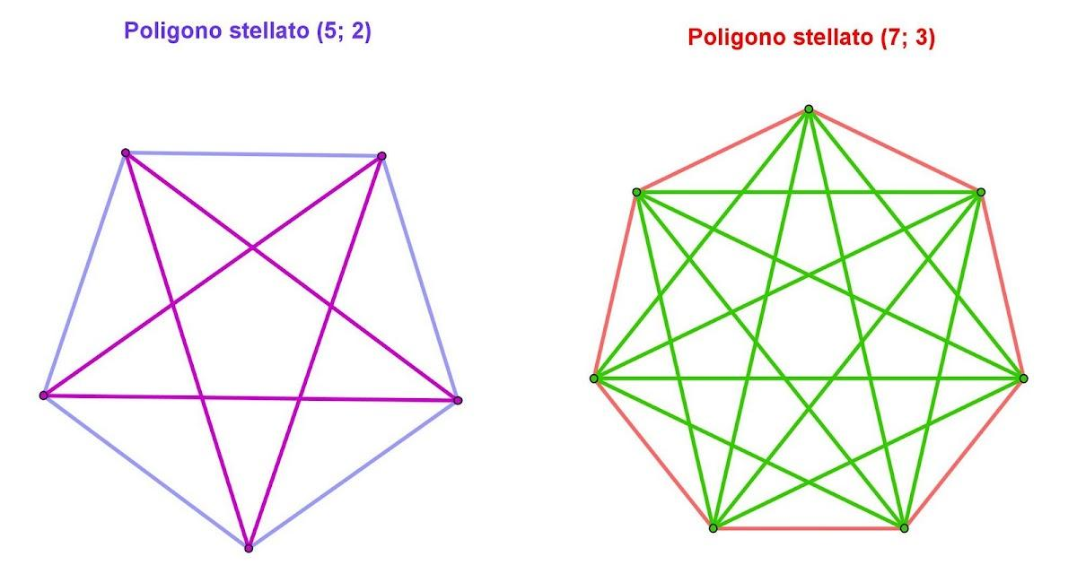
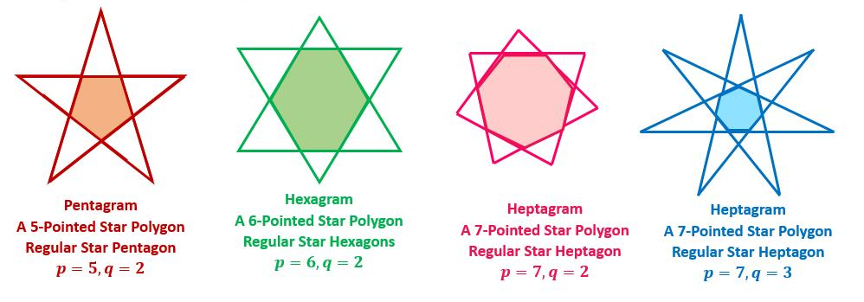
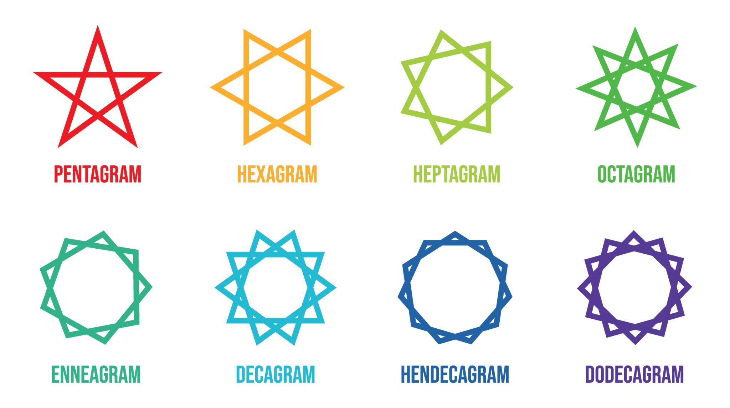
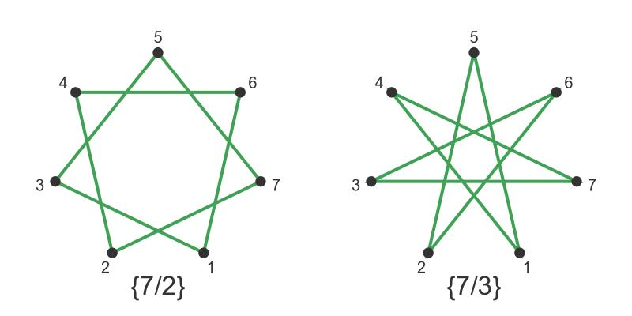
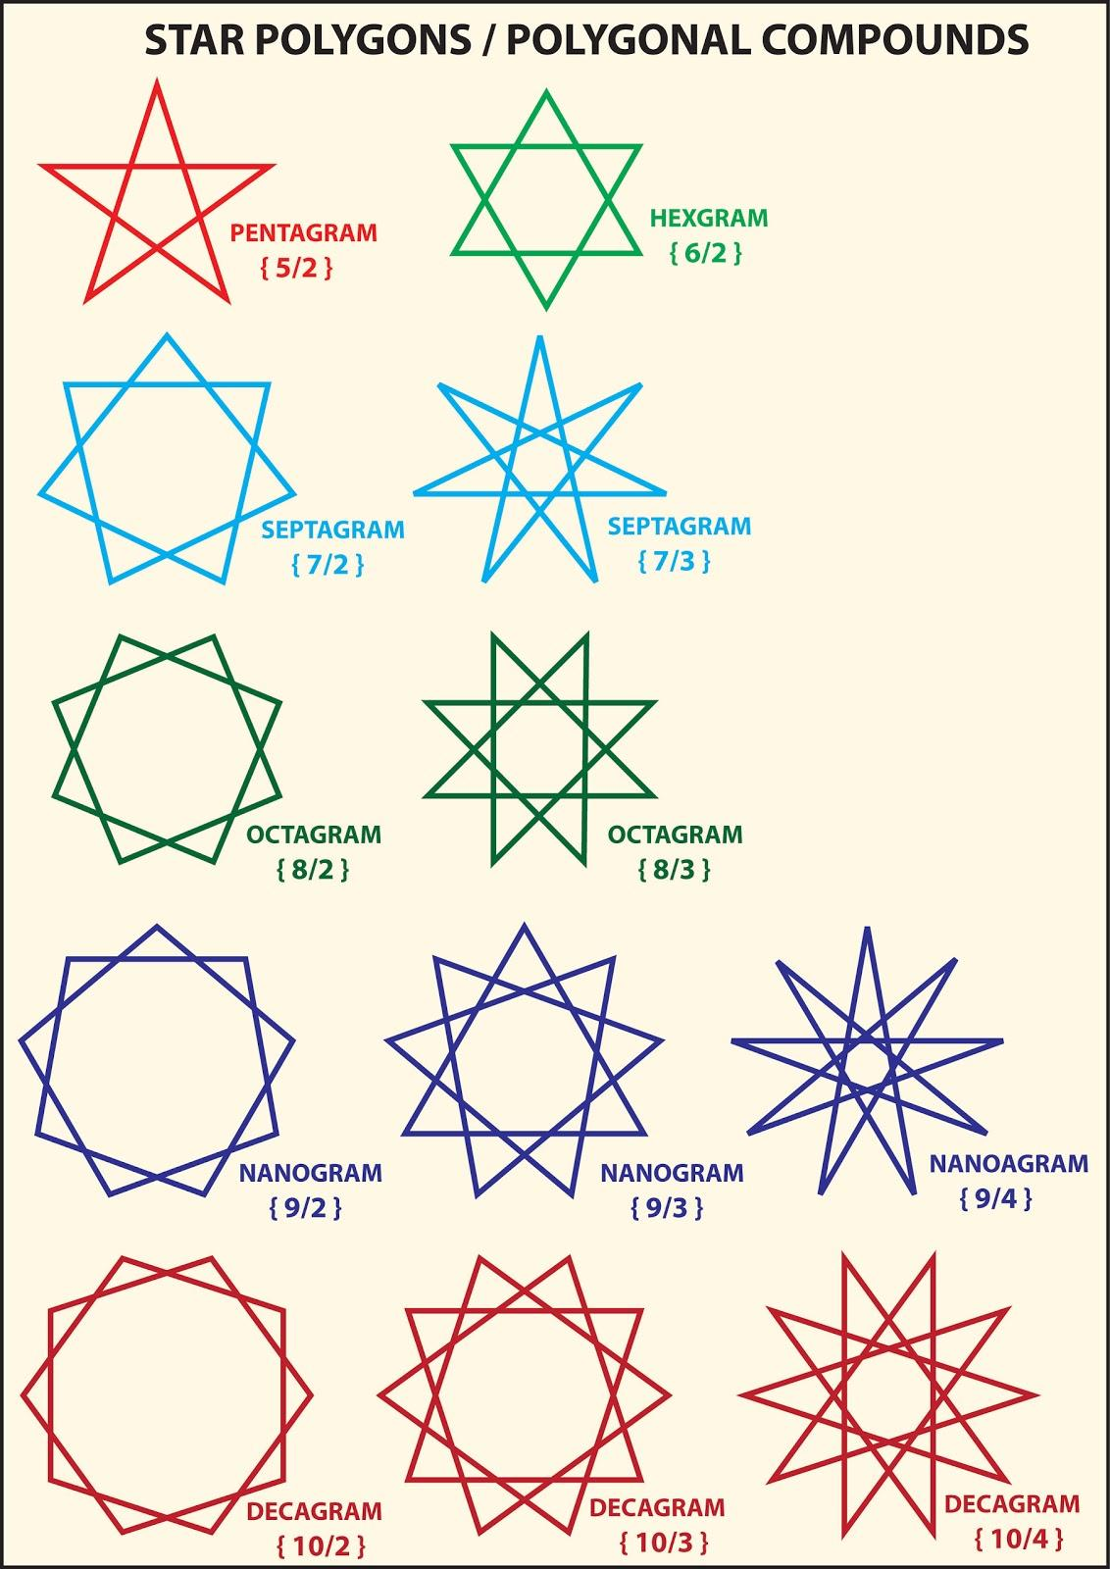

3. Regular Star Polygon
# Source: AI Source: Provided by: [Data Path: Persons Table -> ID Column: 1, Name_En Column: Motasem Essam] -> From: [ChatGPT] on [7/25/2026]
A regular star polygon has a highly symmetrical construction.
Its vertices lie on a common circle, and the edges follow a regular repeating pattern.
Examples include:
$$\left\{5/2\right\}, \left\{7/2\right\}, \left\{7/3\right\}, \left\{8/3\right\}$$
provided the construction satisfies the conditions for a regular star polygon.
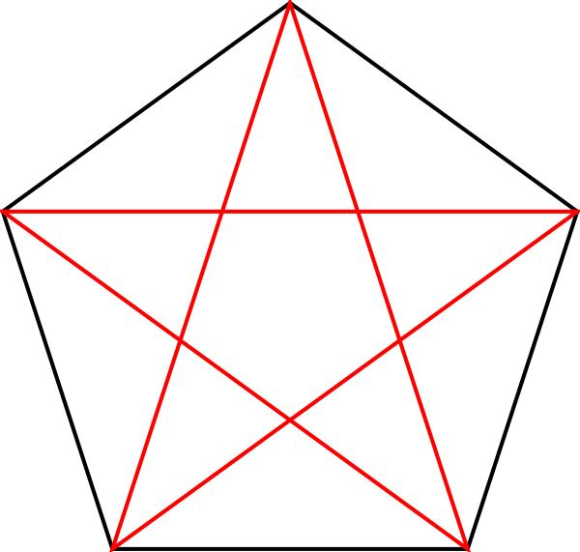
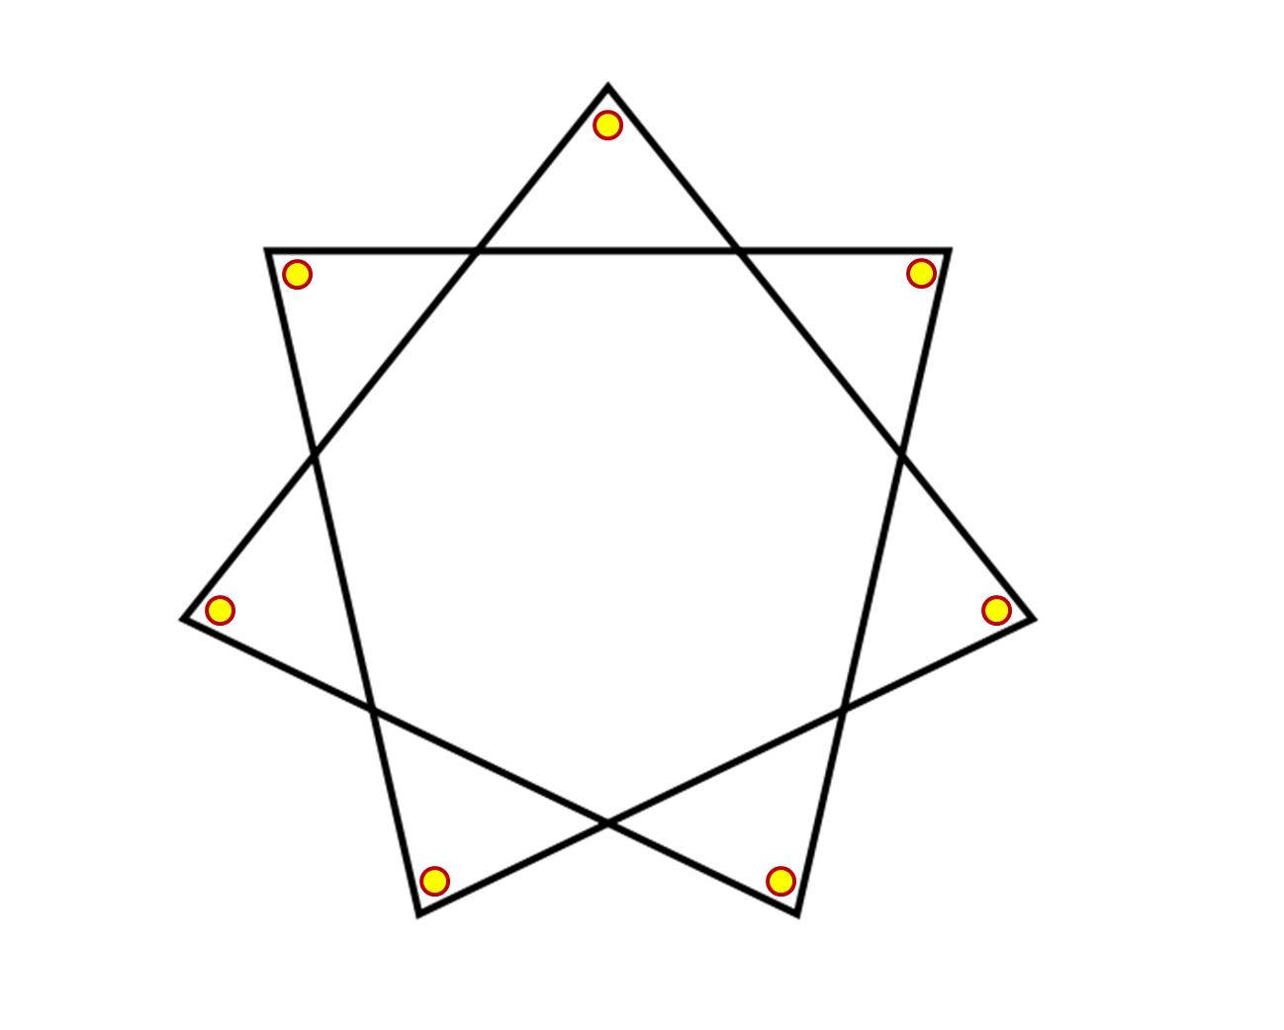
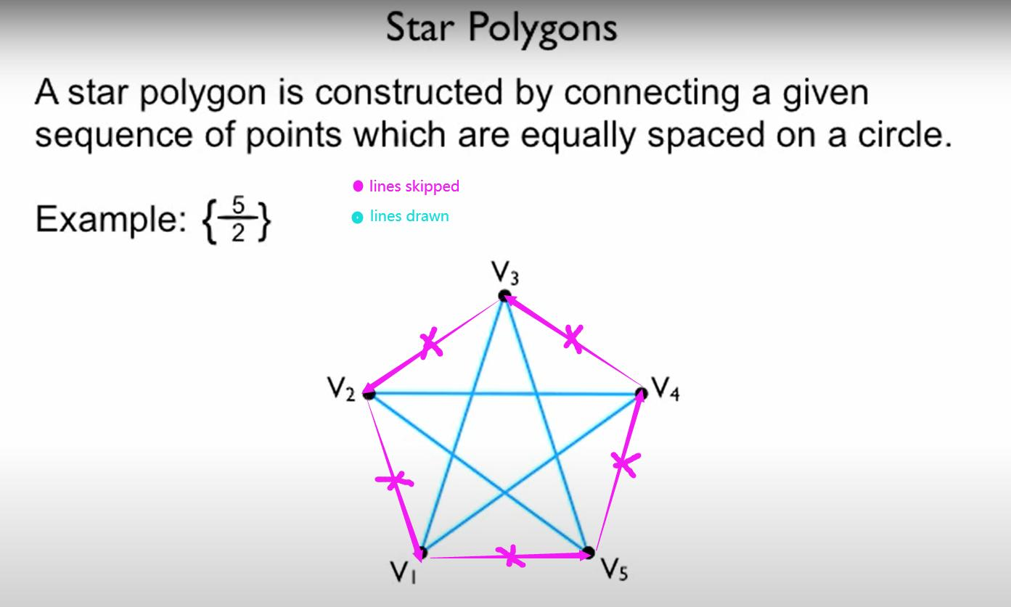

4. Five-Pointed Star
# Source: AI Source: Provided by: [Data Path: Persons Table -> ID Column: 1, Name_En Column: Motasem Essam] -> From: [ChatGPT] on [7/25/2026]
The familiar five-pointed star is the most common star shape.
It can be constructed from:
- 5 outer vertices
- 5 inner vertices
- 10 boundary edges
if its complete outer-and-inner outline is treated as a simple concave polygon.
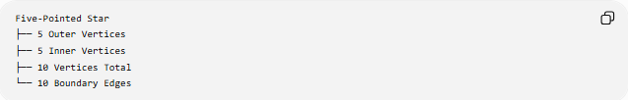
Five-Pointed Star
├── 5 Outer Vertices
├── 5 Inner Vertices
├── 10 Vertices Total
└── 10 Boundary Edges
This should be distinguished from the pentagram, whose five segments cross one another.
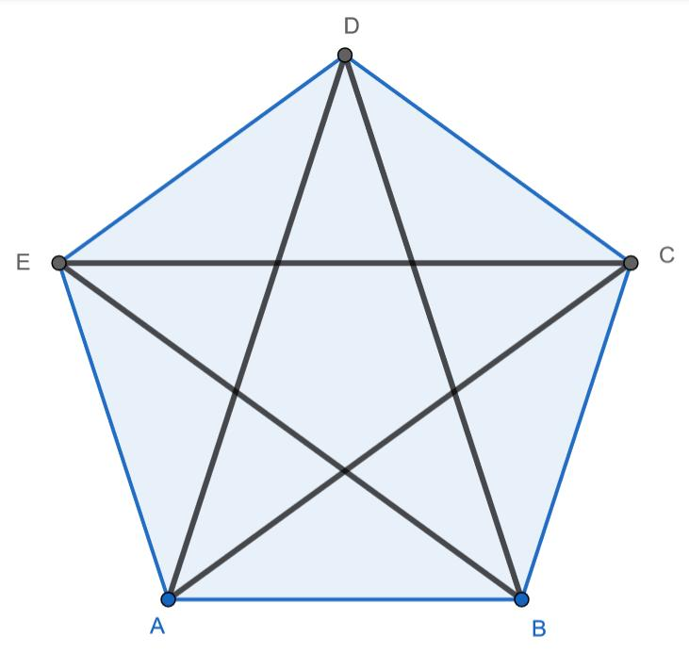
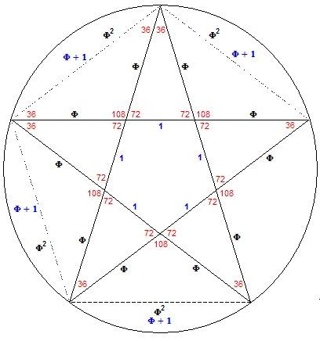
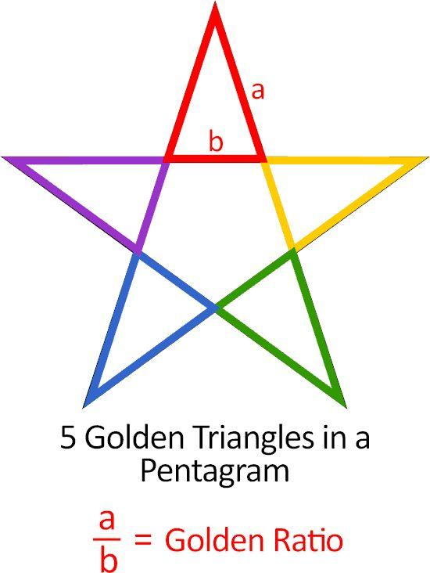
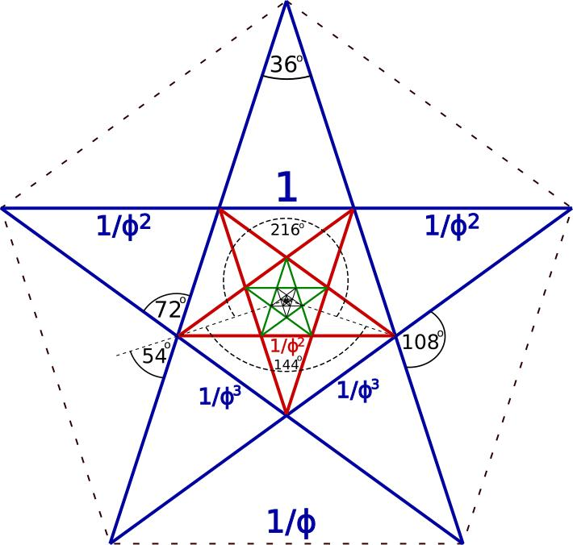

Star Shape vs. Star Polygon vs. Pentagram
# Source: AI Source: Provided by: [Data Path: Persons Table -> ID Column: 1, Name_En Column: Motasem Essam] -> From: [ChatGPT] on [7/25/2026]
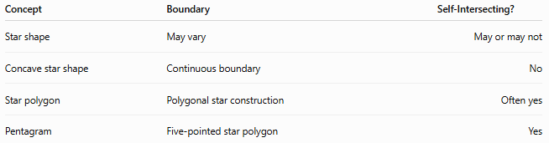
Concept | Boundary | Self-Intersecting?
Star shape | May vary | May or may not
Concave star shape | Continuous boundary | No
Star polygon | Polygonal star construction | Often yes
Pentagram | Five-pointed star polygon | Yes
This distinction is important for a formal geometry taxonomy.

Main Elements
# Source: AI Source: Provided by: [Data Path: Persons Table -> ID Column: 1, Name_En Column: Motasem Essam] -> From: [ChatGPT] on [7/25/2026]
Outer Vertices
The outward-pointing vertices form the tips of the star.
Inner Vertices
The inward vertices form the valleys or indentations between the tips.
Center
The central point or region around which the star is arranged.
Edges
The line segments connecting consecutive vertices.
Points / Tips
The outward projections that give the shape its characteristic appearance.

Symmetry
# Source: AI Source: Provided by: [Data Path: Persons Table -> ID Column: 1, Name_En Column: Motasem Essam] -> From: [ChatGPT] on [7/25/2026]
Many regular star shapes have strong symmetry.
A regular five-pointed star has:
- 5 lines of symmetry
- Rotational symmetry of order 5
Its smallest non-zero rotational symmetry angle is:
$$\frac{{360}^{∘}}{5}={72}^{∘}$$

Star Shape and Concavity
# Source: AI Source: Provided by: [Data Path: Persons Table -> ID Column: 1, Name_En Column: Motasem Essam] -> From: [ChatGPT] on [7/25/2026]
A simple star-shaped polygon is normally concave because some interior angles are greater than ${180}^{∘}$.
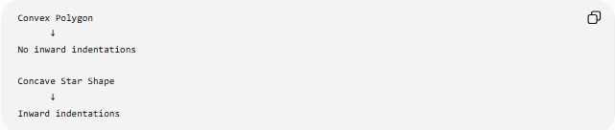
Convex Polygon
↓
No inward indentations

Concave Star Shape
↓
Inward indentations
Therefore, a typical simple five-pointed star belongs under concave polygons.

Star Shape and Self-Intersection
# Source: AI Source: Provided by: [Data Path: Persons Table -> ID Column: 1, Name_En Column: Motasem Essam] -> From: [ChatGPT] on [7/25/2026]
This distinction is especially important:
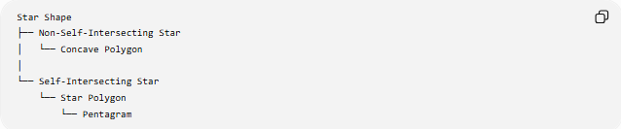
Star Shape
├── Non-Self-Intersecting Star
│ └── Concave Polygon
│
└── Self-Intersecting Star
└── Star Polygon
└── Pentagram
A simple five-pointed star and a pentagram look similar but are mathematically different.

Area
# Source: AI Source: Provided by: [Data Path: Persons Table -> ID Column: 1, Name_En Column: Motasem Essam] -> From: [ChatGPT] on [7/25/2026]
For a simple star-shaped polygon, its area can be calculated by decomposing it into simpler regions or by applying the polygon shoelace formula.
For vertices
$$\left(x_{1} , y_{1}\right),\left(x_{2} , y_{2}\right),…,\left(x_{n} , y_{n}\right)$$
the area is:
$$A=\frac{1}{2}∣\sum_{i=1}^{n}{(}\left.x_{i}y_{i+1}-y_{i}x_{i+1}\right)∣$$
with cyclic indexing:
$$\left(x_{n+1} , y_{n+1}\right)=\left(x_{1} , y_{1}\right)$$
For a self-intersecting star polygon, the interpretation of area requires additional care because the signed contributions from different regions can cancel.

Examples
# Source: AI Source: Provided by: [Data Path: Persons Table -> ID Column: 1, Name_En Column: Motasem Essam] -> From: [ChatGPT] on [7/25/2026]
Example 1 — Simple Five-Pointed Star
A traditional outline star with alternating outer and inner vertices.
Classification:
$$\text{Concave Polygon}$$
Example 2 — Pentagram
A five-pointed star formed by connecting the vertices of a pentagon in a skipping pattern.
Classification:
$$\text{Self-Intersecting Star Polygon}$$
Example 3 — Decorative Star
A graphic star with curved edges or rounded points.
This may not be a polygon at all if its boundary contains curves.

Relationship with Other Shapes
# Source: AI Source: Provided by: [Data Path: Persons Table -> ID Column: 1, Name_En Column: Motasem Essam] -> From: [ChatGPT] on [7/25/2026]
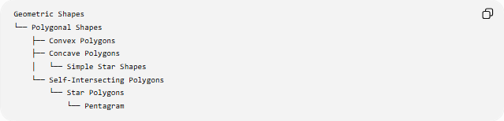
Geometric Shapes
└── Polygonal Shapes
├── Convex Polygons
├── Concave Polygons
│ └── Simple Star Shapes
└── Self-Intersecting Polygons
└── Star Polygons
└── Pentagram

Key Points
# Source: AI Source: Provided by: [Data Path: Persons Table -> ID Column: 1, Name_En Column: Motasem Essam] -> From: [ChatGPT] on [7/25/2026]
- Star shape is a broad visual/geometric term.
- A simple star outline is usually a concave polygon.
- A star polygon is a specific mathematical construction.
- A pentagram is a self-intersecting five-pointed star polygon.
- A simple star and a pentagram should not be classified as the same geometric object.
- Regular star shapes can have rotational and reflectional symmetry.
- Star-shaped objects can also have curved boundaries and therefore need not be polygons.

Conclusion
# Source: AI Source: Provided by: [Data Path: Persons Table -> ID Column: 1, Name_En Column: Motasem Essam] -> From: [ChatGPT] on [7/25/2026]
Star Shape is best treated as a broad category rather than a single precise polygon type. In a formal geometry classification, the important distinction is between simple concave star shapes and self-intersecting star polygons such as the pentagram.

